Create the table and load the data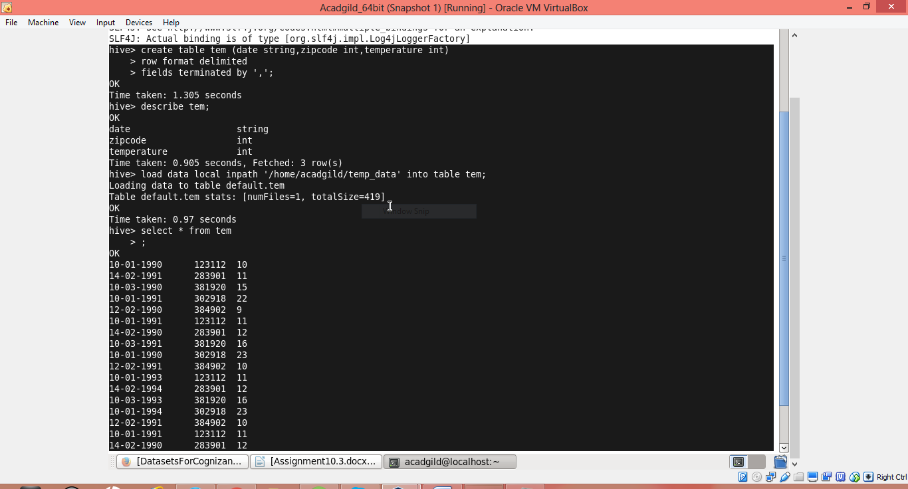

Fetch date and temperature from temperature_data where zip code is greater than 300000 and less than 399999.

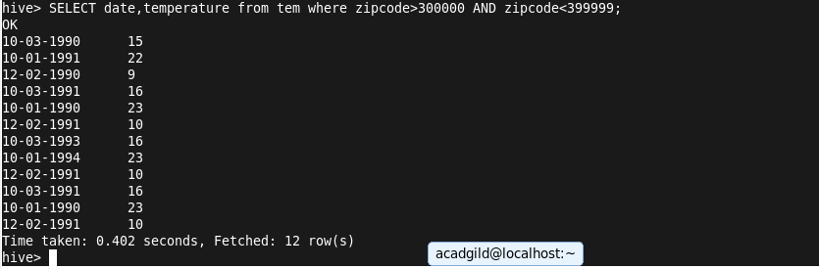

Calculate maximum temperature corresponding to every year from temperature_data table.

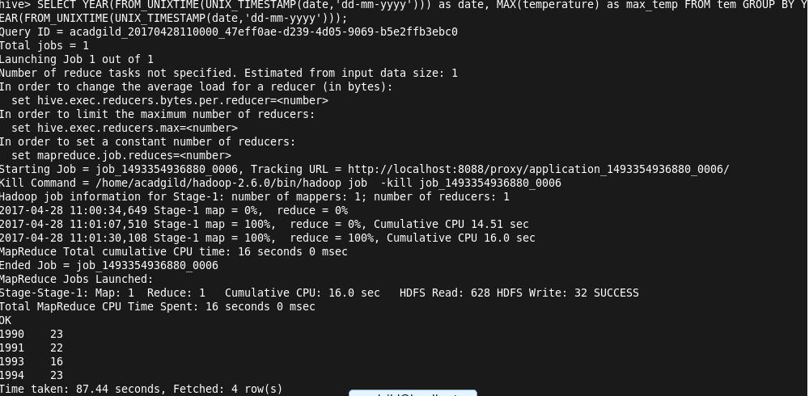

Calculate maximum temperature from temperature_data table corresponding to those years which have at least 2 entries in the table

